**Advance DevOps Experiment 2**

**Aim:** To Build Your Application using AWS CodeBuild and Deploy on S3 / SEBS using AWS CodePipeline, deploy Sample Application on EC2 instance using AWS CodeDeploy(LO2).

**Theory:**

**1. AWS CodePipeline**

AWS CodePipeline is a continuous delivery service you can use to model, visualize, and automate the steps required to release your software. You can quickly model and configure the different stages of a software release process. CodePipeline automates the steps required to release your software changes continuously.

AWS CodePipeline is a fully managed continuous delivery service that helps you automate your release pipelines for fast and reliable application and infrastructure updates. CodePipeline automates the build, test, and deploy phases of your release process every time there is a code change, based on the release model you define. This enables you to rapidly and reliably deliver features and updates. You can easily integrate AWS CodePipeline with third-party services such as GitHub or with your own custom plugin.

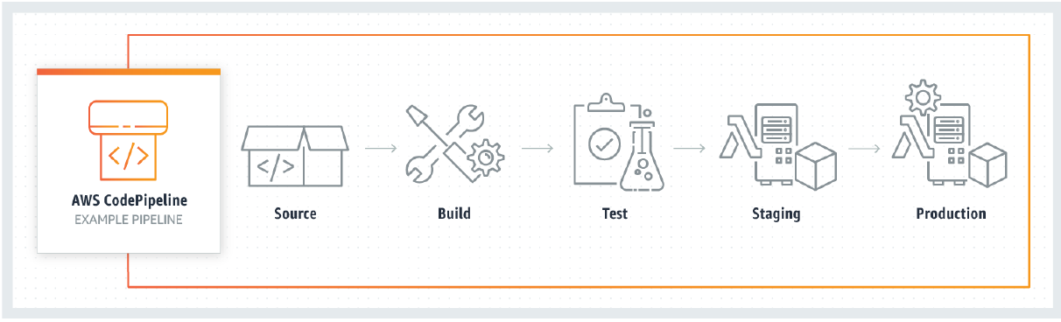

Amazon S3 or Amazon Simple Storage Service is a service offered by Amazon Web Services that provides object storage through a web service interface. To store your data in Amazon S3, you first create a bucket and specify a bucket name and AWS Region. Then, you upload your data to that bucket as objects in Amazon S3. Each object has a key (or key name), which is the unique identifier for the object within the bucket.

AWS Elastic Beanstalk is an orchestration service offered by Amazon Web Services for deploying applications which orchestrates various AWS services, including EC2, S3, Simple Notification Service, CloudWatch, autoscaling, and Elastic Load Balancers.

Amazon(EC2) Elastic Compute Cloud is a part of cloud-computing platform, Amazon Web Services, that allows users to rent virtual computers on which to run their own computer applications.

**2. Benefits of AWS CodePipeline**

a. Rapid delivery

AWS CodePipeline automates your software release process, allowing you to rapidly release new features to your users. With CodePipeline, you can quickly iterate on feedback and get new features to your users faster.

Automating your build, test, and release process allows you to quickly and easily test each code change and catch bugs while they are small and simple to fix. You can ensure the quality of your application or infrastructure code by running each change through your staging and release process.

b. Configurable workflow

AWS CodePipeline allows you to model the different stages of your software release process using the console interface, the AWS CLI, AWS CloudFormation, or the AWS SDKs. You can easily specify the tests to run and customize the steps to deploy your application and its dependencies.

c. Get started fast

With AWS CodePipeline, you can immediately begin to model your software release process. There are no servers to provision or set up. CodePipeline is a fully managed continuous delivery service that connects to your existing tools and systems.

d. Easy to integrate

AWS CodePipeline can easily be extended to adapt to your specific needs. You can use our pre-built plugins or your own custom plugins in any step of your release process. For example, you can pull your source code from GitHub, use your on-premises Jenkins build server, run load tests using a third-party service, or pass on deployment information to your custom operations dashboard.

**Now Below we can see the steps built application using AWS CodeBuild and Deploy on S3 / SEBS using AWS : -**

1. Create a deployment Environment

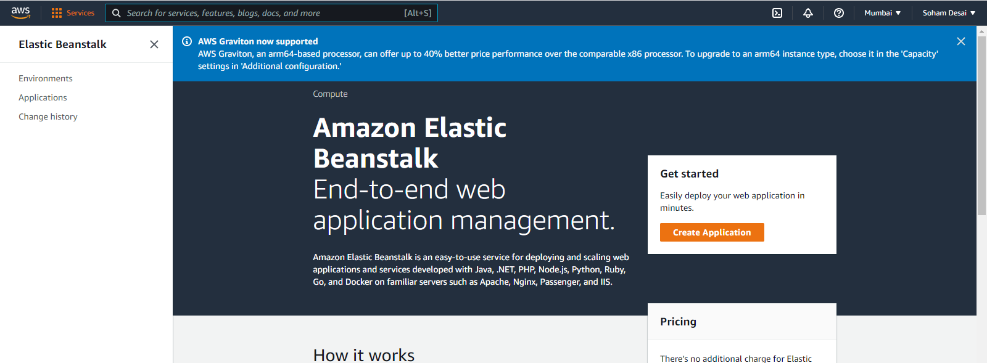

1. Name your Web App and choose PHP from dropdown menu and click on create application

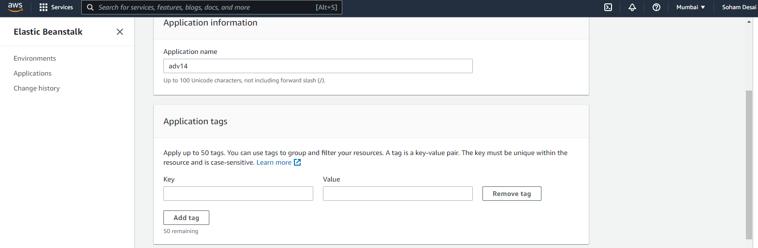

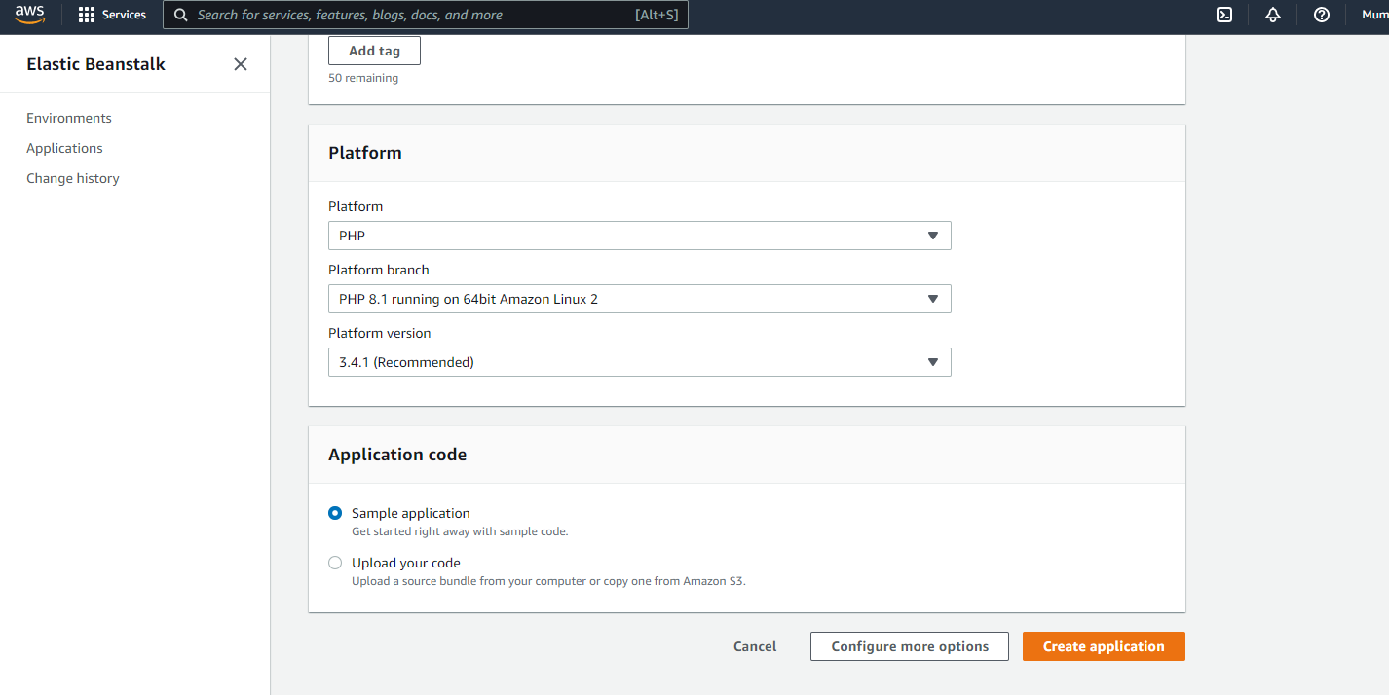

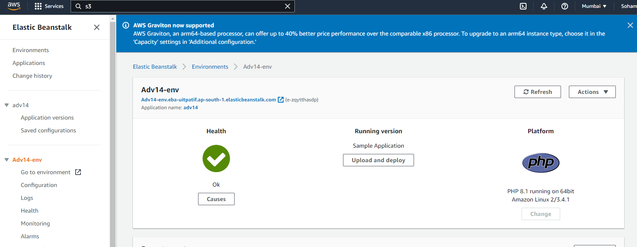

1. Creating your pipeline

